

School of Computing, Engineering and Built Environment

Mobile Platform Development

2023/24
Trimester B

Coursework 1:
PurpleSky Weather App

Module Leader
Allan Bartolome abartolome@alueducation.com

Author: Student Number:
Ganiyat Adekunle S2110996

1.0 Introduction 3
2.0 Software Development Lifecycle (SDLC) 4
2.1 Requirement Gathering and User Stories 4
Table 1: User stories and Functionalities Mapping 4
2.2 Wireframing and Prototyping 5
2.3 Development 5
2.3.1 File Structure and Architecture 6
Figure 1. Project file structure 7
Table 2: Project file structure description 8
2.4 Testing 9
3.0 Testing 10
3.1 Unit Testing 10
Figure 2: Sample code for Junit testing 10
Figure 3: NetworkDataSourceTest (passed) 10
Figure 4: WeatherRepositoryTest (passed) 11
3.2 Functional Testing 11
Table 3: Functional test table 1 11
Table 4: Functional test table with Screenshots 16

1.0 Introduction
This report outlines the Software Development Life Cycle (SDLC) of the android weather app, PurpleSky, a utilitarian weather application targeting users who require minimal weather information for their day-to-day navigation and schedule. The app provides current weather data, a 3-day weather forecast, air quality information, a weather map with weather icon markers and quality data, the ability to compare weather data between two countries, and the option to add a weather widget to the home screen and weather notifications to the notification bar. The app also allows users to customise settings such as turning on/off notifications and removing the widget from the home screen. This report documents the requirement gathering process, the design phase, the development and testing of the PurpleSky weather app. This report focus is mainly on the application testing but the other phases of the SDLC will be discussed briefly.

APK file: https://github.com/Abbiefied/PurpleSky/blob/main/app-release.apk

Video (Google Drive): https://drive.google.com/file/d/1SBR5VIdxwL64oKv1qJ0HzOussuQDkGWu/view?usp=sharing

Video (One Drive): https://1drv.ms/v/c/b43997be2579a257/EaOCqHgGQKdLhDCcwnp4LGIBgPoq7bewVaYyx1IlCemtOg?e=DDucZA

Project Repository: https://github.com/Abbiefied/PurpleSky

2.0 Software Development Lifecycle (SDLC)
This section provides a comprehensive overview of the SDLC for the PurpleSky Android Weather App, detailing the phases from requirement gathering and user stories to wireframing, prototyping, development, and testing. It highlights the importance of adhering to HCI (Human-Computer Interaction) principles in the design and development process, ensuring that the app meets the needs of its users and provides a seamless experience. Through this detailed examination, the section aims to offer insights into the challenges and successes encountered during the app's development, providing valuable lessons for future projects.

2.1 Requirement Gathering and User Stories
The initial phase of the SDLC for the PurpleSky Weather App involved gathering requirements and defining user stories. The target audience for the app was identified as working class individuals, students, and other users who require minimal weather information for daily navigation and scheduling. User stories were created to capture the functionality needed by the users. The user stories are mapped to the application’s functionality/features in the table below.

Table 1: User stories and Functionalities Mapping
User Stories | Functionality/Features
As a user, I want to view the current weather data for my location, including temperature, humidity, wind speed, and weather conditions, so that I can plan my day accordingly. | Current Weather Data
As a user, I want to see a 3-day weather forecast, displaying the predicted temperature range, weather conditions, and precipitation chances for each day, so that I can make informed decisions about my upcoming activities. | Day Weather Forecast
As a user, I want to check the air quality information for my location, including the Air Quality Index (AQI) and pollutant levels, so that I can take necessary precautions for my health and well-being. | Air Quality Information
As a user, I want to view a weather map with weather icon markers indicating the current weather conditions and air quality data for different locations, so that I can get a visual overview of the weather patterns in my area. | Weather Map
As a user, I want to compare weather data between two countries, including temperature, humidity, and weather conditions, so that I can plan my travel and make informed decisions about my destination. | Comparing Weather Data
As a user, I want to add a weather widget to my home screen, displaying the current temperature and weather conditions for my selected location, so that I can quickly access the most relevant weather information without opening the app. | Home Screen Widget
As a user, I want to receive weather notifications in the notification bar, alerting me about significant changes in weather conditions, severe weather alerts, or important updates, so that I can stay informed and take necessary actions. | Weather Notifications
As a user, I want to customise the app settings, such as turning on/off notifications, refreshing weather data, and choosing the frequency of data updates, so that I can tailor the app to my preferences and control the flow of information. | Customizable Settings
As a user, I want to have offline access to the most recently downloaded weather data, so that I can still view basic weather information even when I don't have an internet connection. | Offline Access

2.2 Wireframing and Prototyping
Wireframing was done using pencil and paper to outline the basic layout and functionality of the app. This initial sketch helped in visualising the app's structure and identifying potential design issues early on. Following the wireframing phase, prototyping was conducted using Figma. The prototyping phase focused on creating interactive mockups of the app, adhering to HCI (Human-Computer Interaction) principles such as:
- Consistency: Maintained a consistent design language and user interface elements throughout the app.
- Simplicity: Kept the user interface clean and intuitive, focusing on essential information and minimising clutter.
- Familiarity: Used familiar icons with text labels and design patterns to enhance usability and reduce the learning curve.
- Feedback: Provided clear and immediate feedback to users through visual cues and notifications.
- Accessibility: Ensured the app is accessible to users with different abilities and adheres to accessibility guidelines.

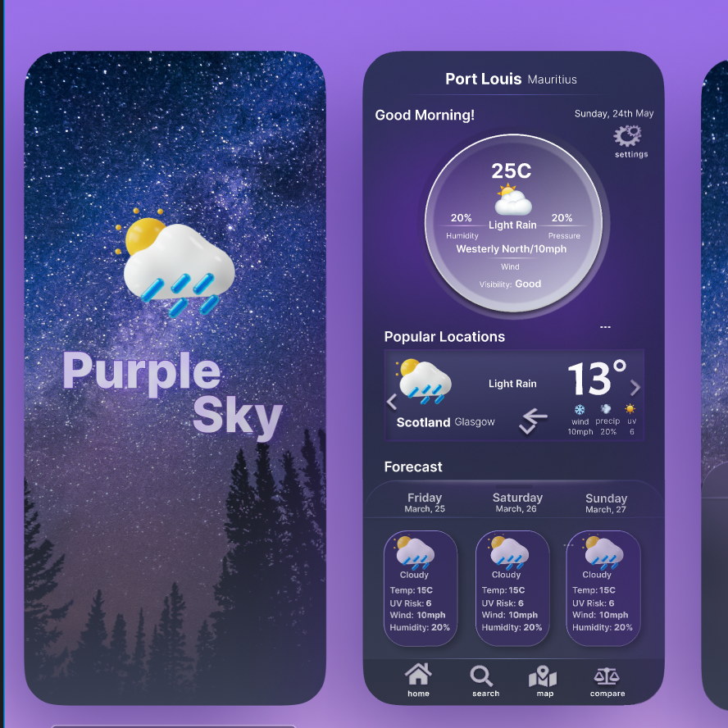

Figure1: Figma design

2.3 Development

The development phase was approached iteratively, starting with a minimal UI to focus on the backend functionality first. This approach allowed for the early testing and validation of the app's core features, such as fetching and parsing weather data from the internet using XMLPullParser, integrating the Google Maps API for the weather map and air quality data, and implementing the functionality for comparing weather data between two countries.The app was developed using Android Studio with Java for the backend and XML for the user interface.
As the backend was developed and tested, the UI was progressively enhanced to match the design specifications, ensuring that the app's appearance and functionality were aligned with the user requirements. The Model-View-ViewModel (MVVM) architecture pattern was used to separate concerns and improve code maintainability.

2.3.1 File Structure and Architecture
The Model-View-ViewModel (MVVM) architecture used in the PurpleSky weather app provides a structured and maintainable approach to building the application. It promotes separation of concerns, testability, and code reusability. To explain how the MVVM architecture was used and its advantage over other simpler architecture such as Model-View-Controller (MVC), it is important to understand the file structure. Below is an image of the file structure and the table that describes each folder and subfolders.
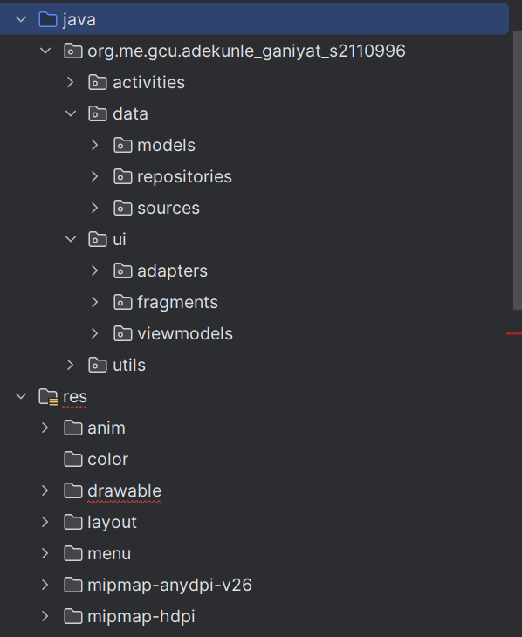

Figure 2. Project file structure

Table 2: Project file structure description
Folder/Subfolders | Description
activities | Contains Activity classes responsible for handling user interactions and managing fragments.
data  - models  - repositories  - sources | Defines the data models used in the application, representing entities such as weather data, location, etc.
data  - models  - repositories  - sources | Implements repository classes that abstract data access and provide a single source of truth for data.
data  - models  - repositories  - sources | Contains classes responsible for fetching data from various sources, such as the internet and local data source.
ui  - adapters  - fragments  - viewmodels | Holds adapter classes used for populating data in RecyclerViews and other UI components.
ui  - adapters  - fragments  - viewmodels | Contains Fragment classes representing different screens or portions of the user interface.
ui  - adapters  - fragments  - viewmodels | Defines ViewModel classes that encapsulate the UI-related data and logic, acting as a bridge between the UI and the data layer.
utils | Contains utility classes and helper functions used throughout the application.
res | Holds various resource directories, such as layouts, drawables, animations, colours, menus, and values.

The key components of MVVM are:
- Model: Represents the data and business logic of the application. In this project, the data package contains the models, repositories, and source subpackages, which handle data-related operations and business logic. The models define the structure of the data, the repositories provide an abstraction layer for data access, and the sources handle the actual data retrieval from APIs and local storage.
- View: Responsible for displaying the user interface and capturing user interactions. The ui package contains the fragments and adapters subpackages. The fragments represent different screens or portions of the UI, while the adapters are used to populate data in UI components like RecyclerViews.
- ViewModel: Acts as an intermediary between the Model and the View. The viewmodels subpackage within the ui package contains the ViewModel classes. ViewModels expose data to the UI and handle user actions, keeping the UI logic separate from the data and business logic.

2.4 Testing
Testing was a critical phase in the SDLC, involving both unit testing with JUnit and functional testing to ensure that the app met its requirements and provided a seamless user experience. Unit tests were used to verify the correctness of individual components, such as the weather data parsing logic and the Google Maps integration. Functional tests were conducted to ensure that the app's features worked together as expected, from fetching and displaying weather data to integrating with the Google Maps API and allowing users to customise the app's settings.

3.0 Testing

3.1 Unit Testing
Unit testing was carried out using Junit and Roboelectric. All the tests passed as shown in the pictures below:

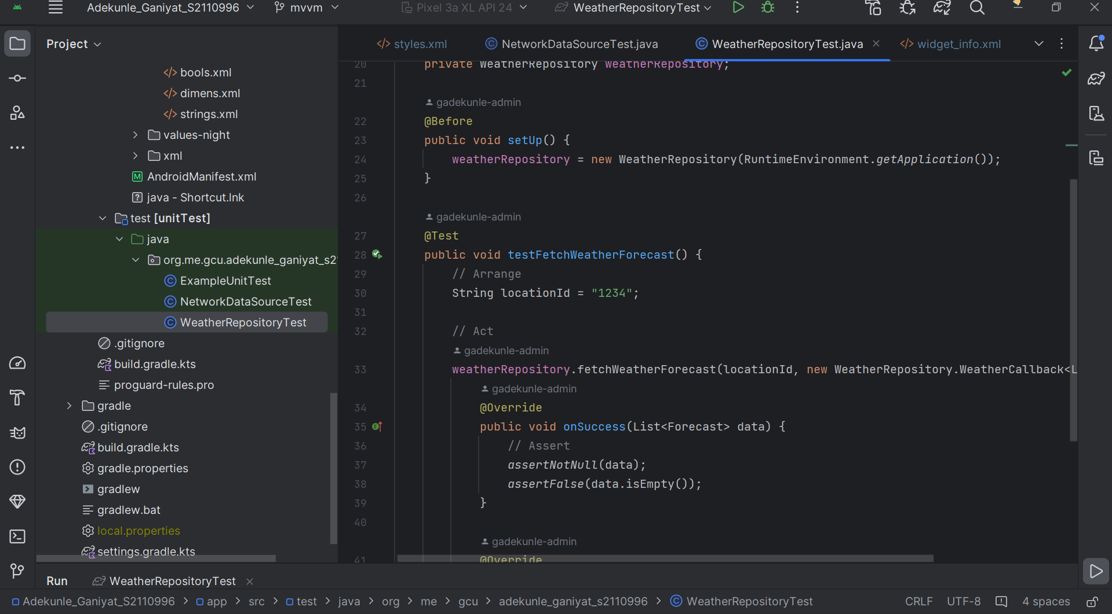

Figure 3: Sample code for Junit testing

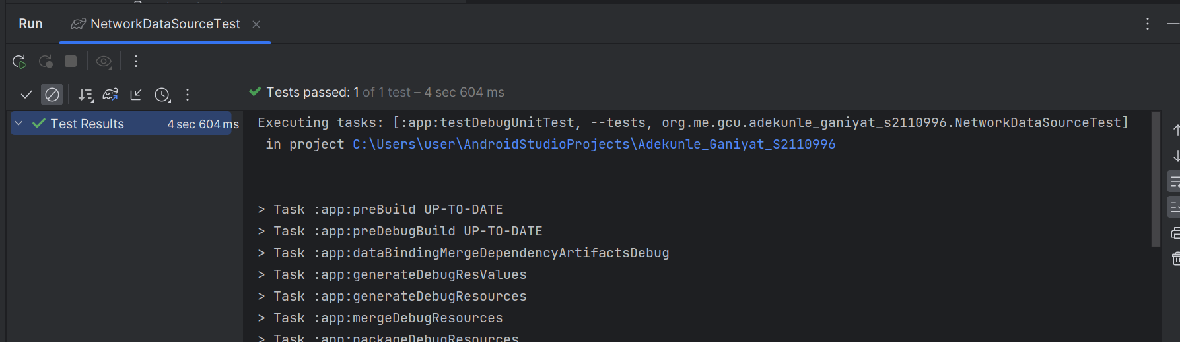

Figure 4: NetworkDataSourceTest (passed)

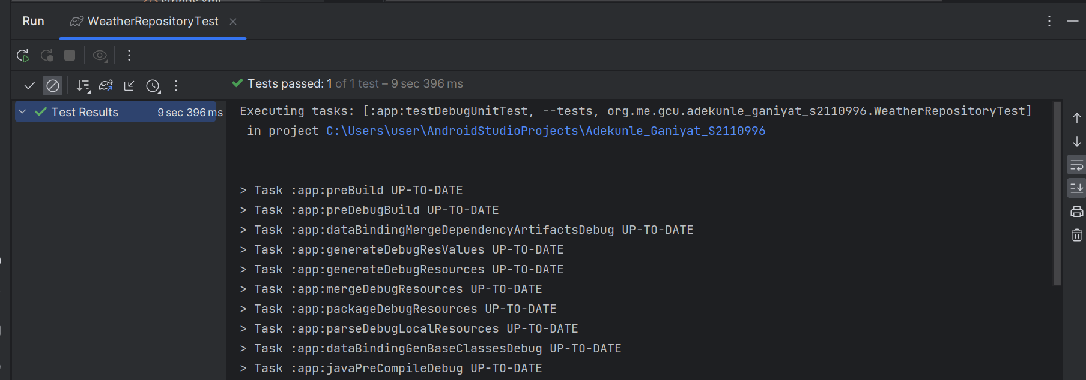

Figure 5: WeatherRepositoryTest (passed)

3.2 Functional Testing

Table 3: Functional test table 1
Test Case ID | Test Case Description | Preconditions | Test Steps | Expected Result | Pass/Fail
TC_01 | View current weather data | -App installed  -Internet connection available | -Launch the app  -Allow location permission  -View the current weather data on the main screen | Current weather data is displayed accurately for the default location (Glasgow) | Pass
TC_02 | View each day detailed weather forecast | -App installed  -Internet connection available | -Launch the app  -Navigate to the detailed forecast screen by clicking one of the forecast cards on the main screen  -View the specific day detailed weather forecast | Detailed weather forecast is displayed accurately for the specific day | Pass
TC_03 | View weather map with weather icon marker and air quality data markers | -App installed  -Internet connection available | -Launch the app  -Navigate to the weather map screen  -View weather map with weather icon marker and air quality data markers | Weather map is displayed with accurate weather icon marker and air quality data markers.  Weather icon marker display infowindow with weather data on click.  Air quality marker navigates to the air quality screen on click.
TC_04 | Search for a location and display its weather map | -App installed  -Internet connection available  -The weather map screen is in view | -Enter location name in the search box  -Click the search icon to search  -View weather map with weather icon marker and air quality data markers for the searched location | Weather map for the searched location is displayed with accurate weather icon marker and air quality data markers.  Weather icon marker displays infowindow with weather data on click.  Air quality marker navigates to the air quality screen on click. | Pass
TC_05 | View air quality data | -App installed  -Internet connection available  -The weather map screen is in view with the air quality label marker | -Click the air quality marker to navigate to the air quality screen  -View the air quality data | Air quality data is displayed accurately for the specific location | Pass
TC_06 | Search for a location and display its weather data on the main screen | -App installed  -Internet connection available | -Launch the app  -Navigate to the search screen  -Enter the location name in the search box  -Press enter or click the search icon  -View the weather data for the searched location on the main screen | Weather data for the searched location is displayed on the main screen. The searched location is added to the recent locations. | Pass
TC_07 | Compare weather data between two countries | -App installed  -Internet connection available | -Launch the app  -Navigate to the weather comparison screen  -Select two countries in the location spinners  -View the weather comparison data | Weather data comparison is displayed accurately for the selected countries with a summary of the comparison | Pass
TC_08 | Refresh Data | -App installed  -Internet connection available | -Launch the app  -Navigate to the settings screen  -Click the refresh icon | Weather data is refreshed and a success message is displayed.  Note: Auto refresh at 8 am and at 10pm is implemented too | Pass
TC_09 | Set data refresh time | -App installed  -Internet connection available | -Launch the app  -Navigate to the settings screen  -Set the desired time for the refresh | The time was set successfully and the settings summary was updated | pass
TC_10 | Add weather widget to home screen | - App installed  -Widget not already added | - Launch the app  -Navigate to the widget settings  -Check the “Add widget to homescreen” settings  -Go to phone settings to add the created widget to home screen | The widget is added to the home screen and displays current weather data and data is refreshed by clicking the refreshed icon. | pass
TC_11 | Add weather notification to notification bar | - App installed  -Notification not already enabled | -Launch the app  -Navigate to the notification settings  -Enable weather notifications | Weather notifications are successfully added to the notification bar and provide updates | pass
TC_12 | View application in landscape orientation | -App is installed | Launch the app in landscape orientation or launch the app in portrait orientation and switch the orientation to landscape | App adjust to make use of the available space and the some UI elements are re-arranged | pass

Table 4: Functional test table with Screenshots
Test Case ID | Test Case Description | Actual Result | Image
TC_01 | View current weather data | Current weather data is displayed accurately for the default location (Glasgow) | 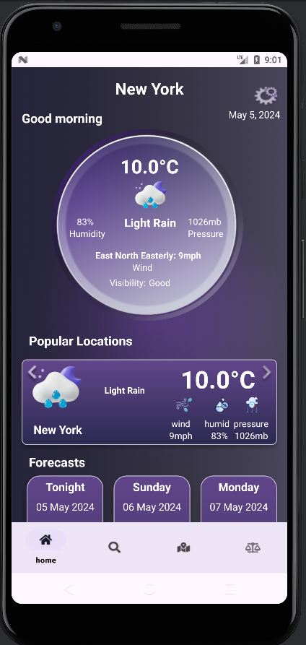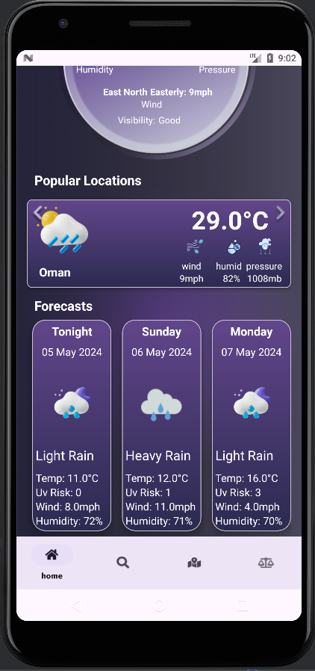
TC_02 | View each day detailed weather forecast | Detailed weather forecast is displayed accurately for the specific day | 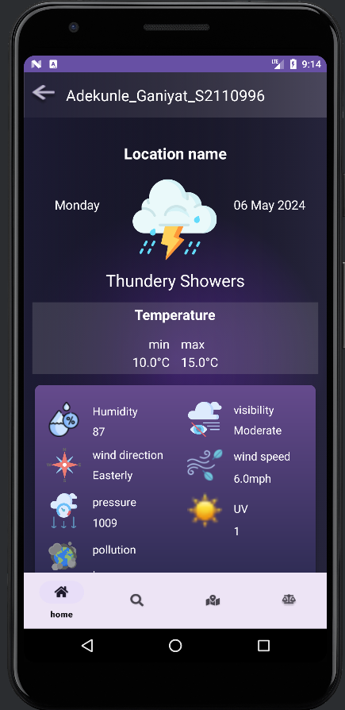
TC_03 | View weather map with weather icon marker and air quality data markers | Weather map is displayed with accurate weather icon marker and air quality data markers.  Weather icon marker display infowindow with weather data on click.  Air quality marker navigates to the air quality screen on click. | 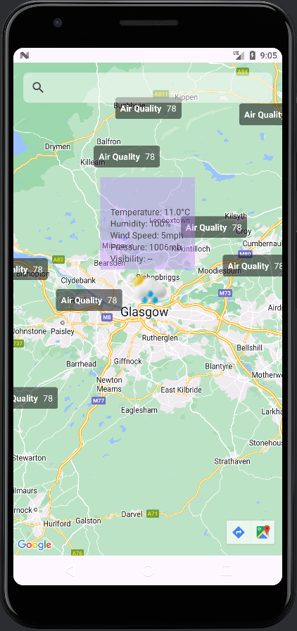
TC_04 | Search for a location and display its weather map | Weather map for the searched location is displayed with accurate weather icon marker and air quality data markers.  Weather icon marker displays infowindow with weather data on click.  Air quality marker navigates to the air quality screen on click. | 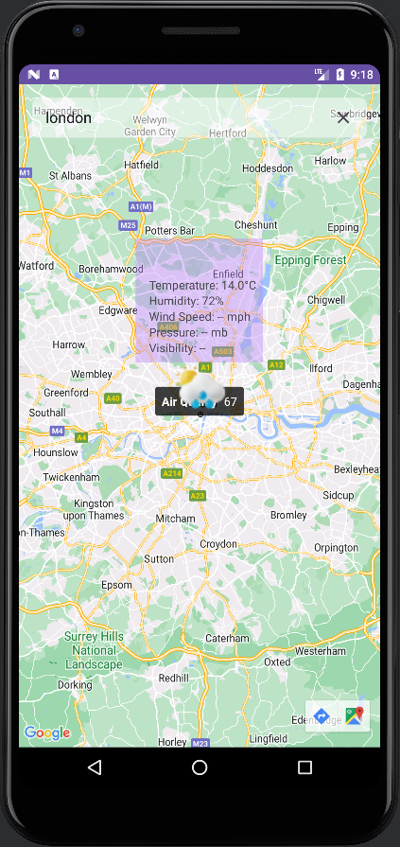
TC_05 | View air quality data | Air quality data is displayed accurately for the specific location | 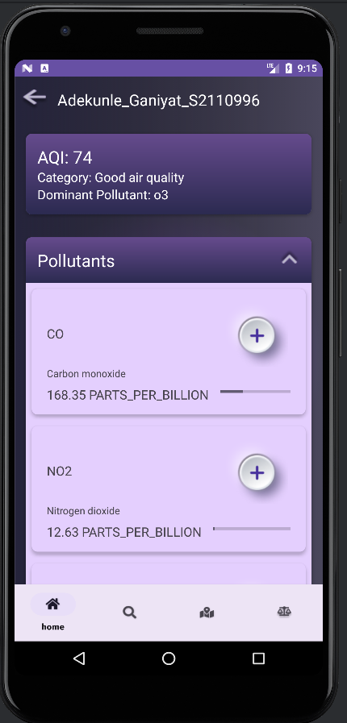  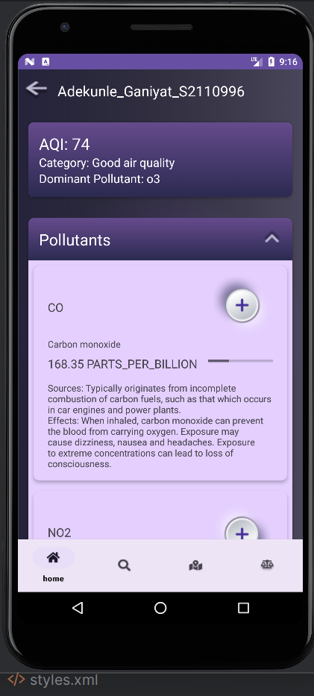
TC_06 | Search for a location and display its weather data on the main screen | Weather data for the searched location is displayed on the main screen. The searched location is added to the recent locations. | 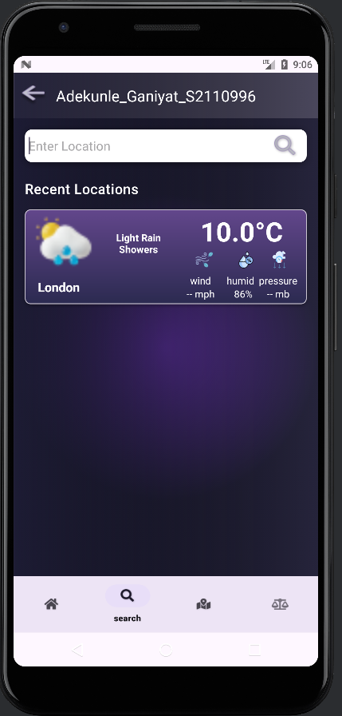
TC_07 | Compare weather data between two countries | Weather data comparison is displayed accurately for the selected countries with a summary of the comparison | 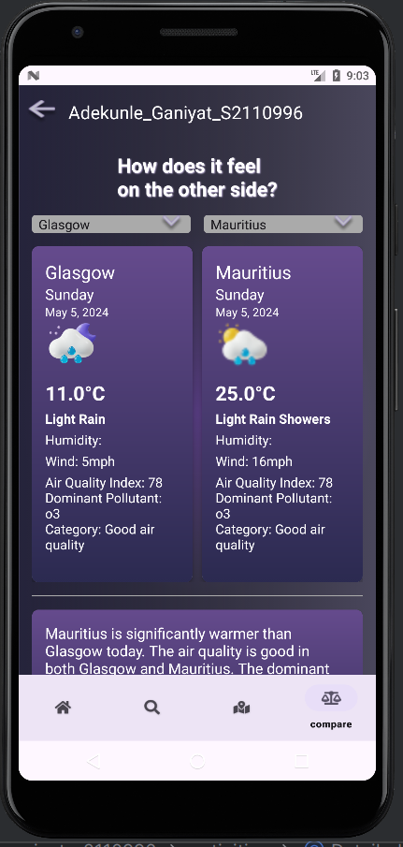  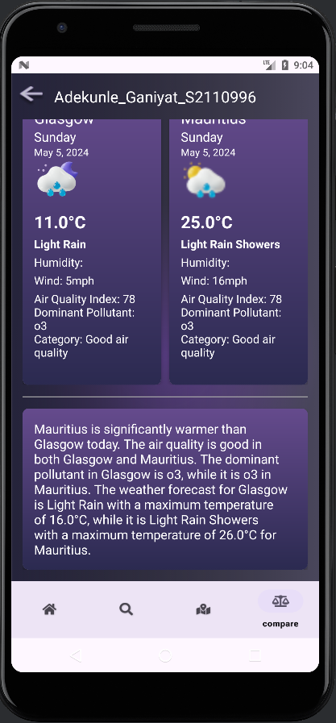
TC_08 | Refresh Data | Weather data is refreshed and a success message is displayed.  Note: Auto refresh at 8 am and at 10pm is implemented too | 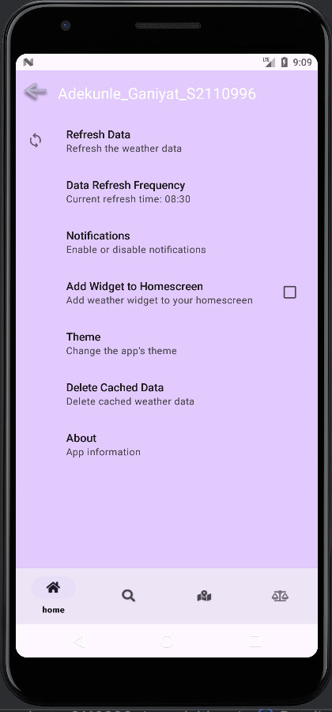  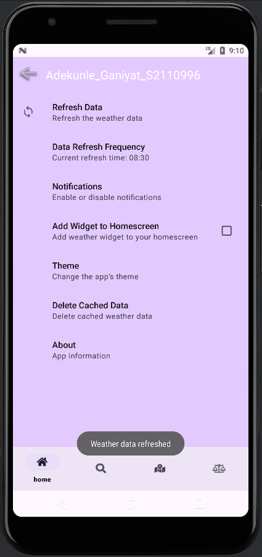
TC_09 | Set data refresh time | The time was set successfully and the settings summary was updated | 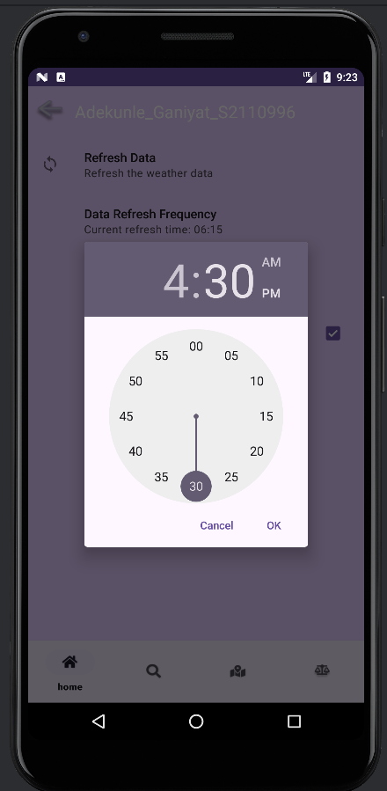  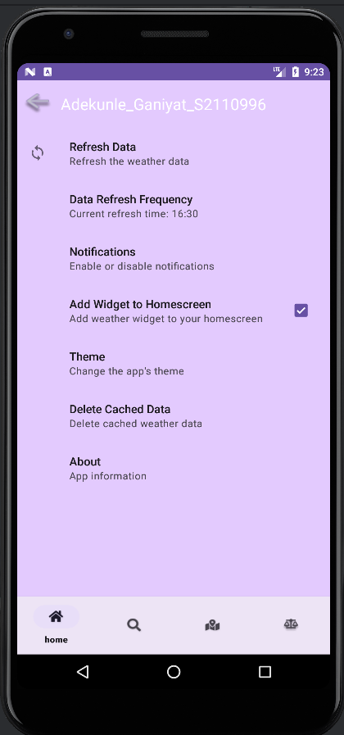
TC_10 | Add weather widget to home screen | The widget is added to the home screen and displays current weather data and data is refreshed by clicking the refreshed icon. | 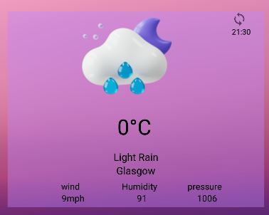
TC_11 | Add weather notification to notification bar | Weather notifications are successfully added to the notification bar and provide updates | 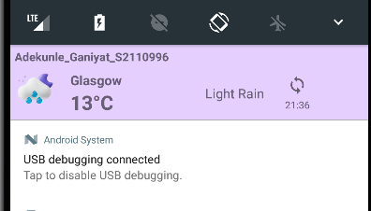
TC_12 | View application in landscape orientation | App adjust to make use of the available space and the some UI elements are re-arranged | 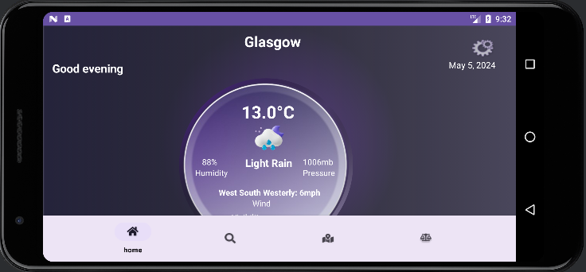  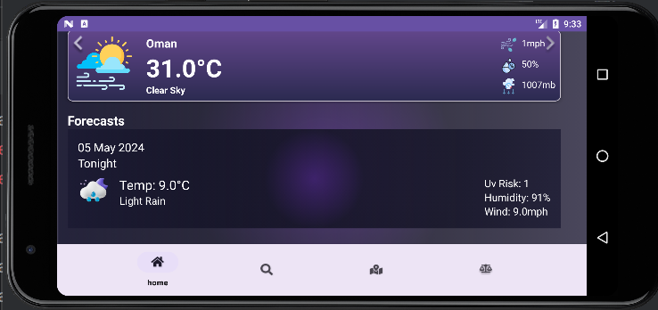

Main Screen 1

Main screen2

Detailed Weather Forecast

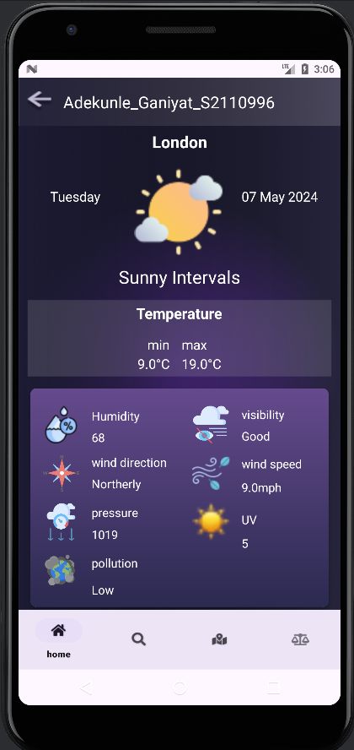

Compare location screen 1

Compare location screen 2

Airquality Data (not expanded)

Airquality Data (Expanded)
Search Location

Weather map

Set refresh time 1
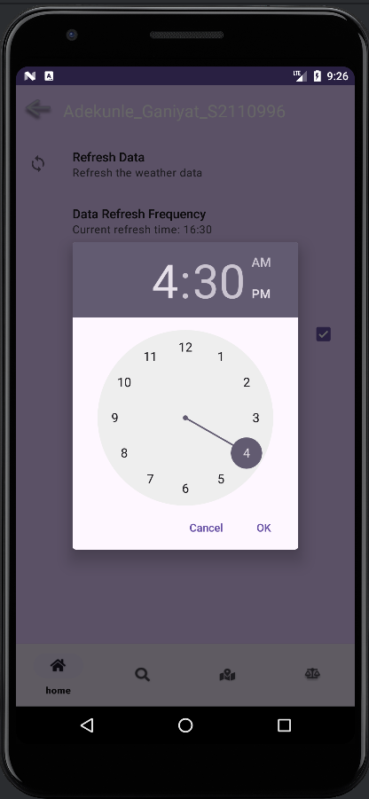

Set refresh time 2 (Summary updated)

Search location

Refresh data

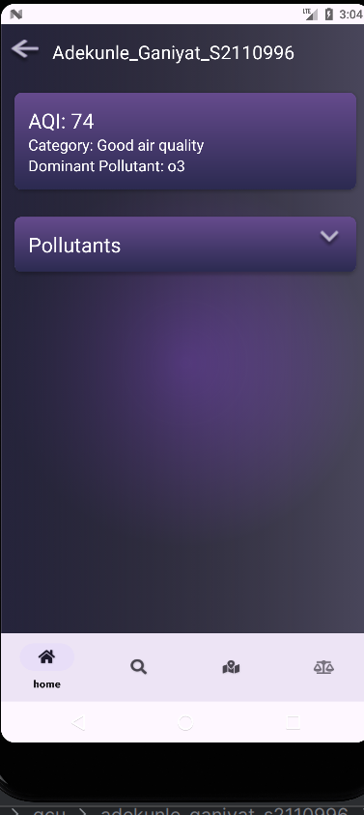
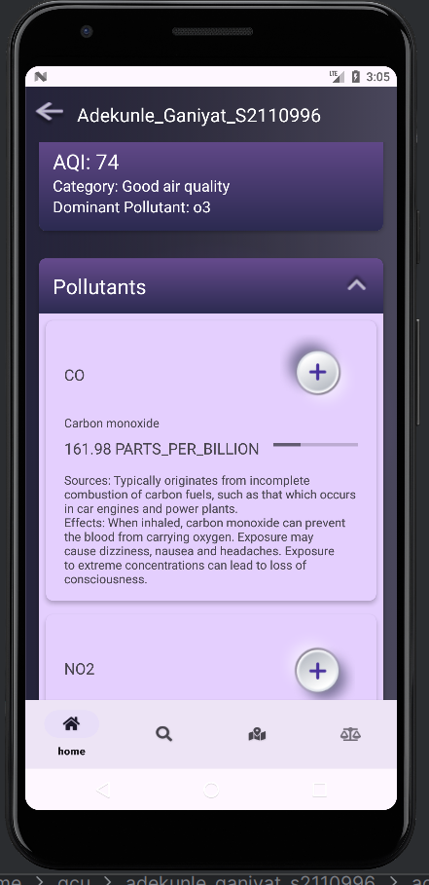
Weather notification bar

Weather widget

